|  |  |  |
| --- | --- | --- |
| **LAB101 Assignment** | **Type:** | **Short Assignment** |
| **Code:** | **C.S.P0041** |
| **LOC:** | **37** |
| **Slot(s):** | **1** |

**Title**

Array Manipulations.

**Background**

N/A

**Program Specifications**

Implement a program with the following functions

* Input an integer which is the size of an array (the array size is up to 100).
* Output the max element in the array.
* Output all array’s elements.
* Output all even elements in the array.

***Function details:***

1. Users can limit the array size.
2. Users input array’s elements.
3. The program displays all the array’s elements.
4. The program displays the max element in the array.
5. The program displays all the even numbers in the array.

***Expectation of User interface:***

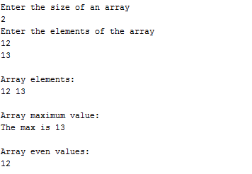

**Guidelines**

An even number is the number being divisible by 2.